**PIZZA SALES SQL QUERIES**

**A. KPI’s**

**1. Total Revenue:**

SELECT ROUND(SUM(total_price):: numeric, 2) AS Total_Revenue

FROM pizza_sales;

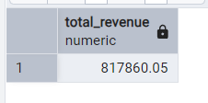

**2. Average Order Value**

SELECT ROUND(

SUM(total_price):: numeric /

COUNT(DISTINCT order_id):: numeric, 2) AS Avg_order_Value

FROM pizza_sales;

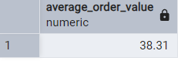

**3. Total Pizzas Sold**

SELECT SUM(quantity) AS Total_pizza_sold

FROM pizza_sales;

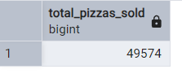

**4. Total Orders**

SELECT COUNT(DISTINCT order_id) AS Total_Orders

FROM pizza_sales;

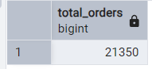

**5. Average Pizzas Per Order**

SELECT CAST(CAST(SUM(quantity) AS DECIMAL(10,2)) /

CAST(COUNT(DISTINCT order_id) AS DECIMAL(10,2)) AS DECIMAL(10,2)) AS average_pizzas_per_order

FROM pizza_sales;

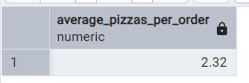

**B. Daily Trend for Total Orders**SELECT TO_CHAR(order_date, ‘Day’) AS order_day,

COUNT(DISTINCT order_id) AS total_orders

FROM pizza_sales

GROUP BY TO_CHAR(order_date, ‘Day’)

ORDER BY 2 DESC;

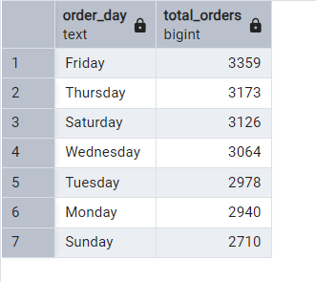

**C. Monthly Trend for Orders**

SELECT TO_CHAR(order_date, ‘MONTH’) AS month_name,

COUNT(DISTINCT order_id) AS total_orders

FROM pizza_sales

GROUP BY TO_CHAR(order_date, ‘MONTH’)

ORDER BY 2 DESC;

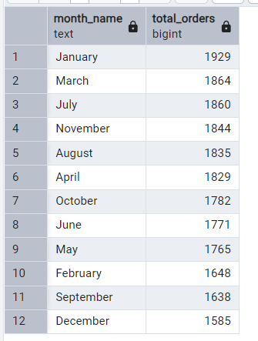

**D. % of Sales by Pizza Category**

SELECT pizza_category,

ROUND(SUM(total_price):: numeric, 2) AS total_sales,

CAST(SUM(total_price) * 100 / (SELECT SUM(total_price) FROM pizza_sales) AS DECIMAL(10,2)) AS percentage_of_sales

FROM pizza_sales

GROUP BY pizza_category;

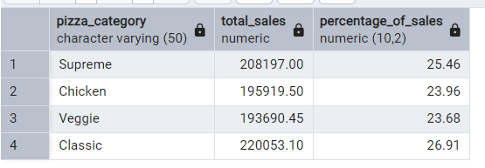

**E. Percentage of Sales by Pizza Size**

SELECT pizza_size,

ROUND(SUM(total_price):: numeric, 2) as total_sales,

CAST(SUM(total_price) * 100 /

(SELECT SUM(total_price) FROM pizza_sales) AS DECIMAL (10,2)) AS percentage_of_sales

FROM pizza_sales

GROUP BY pizza_size

ORDER BY percentage_of_sales DESC;

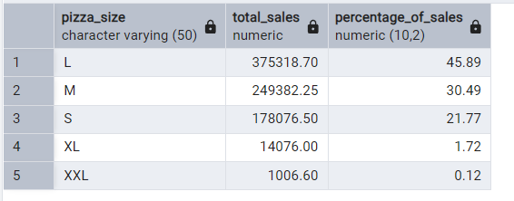

**F. Total Pizzas Sold by Pizza Category**

SELECT pizza_category,

SUM(quantity) AS total_quantity_sold

FROM pizza_sales

GROUP BY pizza_category

ORDER BY total_quantity_Sold DESC;

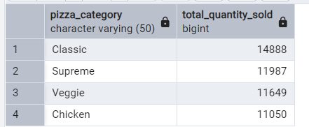

**G. Top 5 Pizzas by Revenue**

SELECT pizza_name,

SUM(total_price) AS total_revenue

FROM pizza_sales

GROUP BY pizza_name

ORDER BY total_revenue DESC

LIMIT 5;

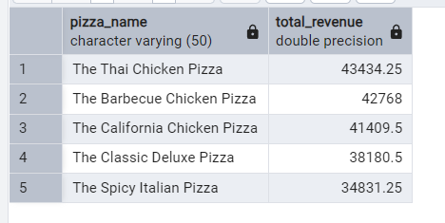

**H. Bottom 5 Pizzas by Revenue**

SELECT pizza_name,

SUM(total_price) AS total_revenue

FROM pizza_sales

GROUP BY pizza_name

ORDER BY total_revenue ASC

Limit 5;

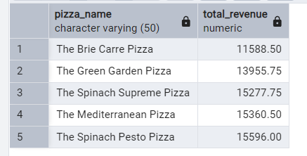

**I. Top 5 Pizzas by Quantity**

SELECT pizza_name,

SUM(quantity) AS total_pizza_sold

FROM pizza_sales

GROUP BY pizza_name

ORDER BY total_pizza_sold DESC

LIMIT 5;

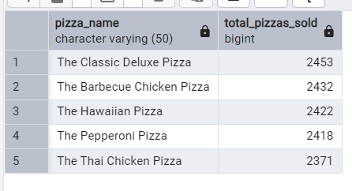

**J. Bottom 5 Pizzas by Quantity**

SELECT pizza_name,

SUM(quantity) AS total_pizza_sold

FROM pizza_sales

GROUP BY pizza_name

ORDER BY total_pizza_sold ASC

LIMIT 5;

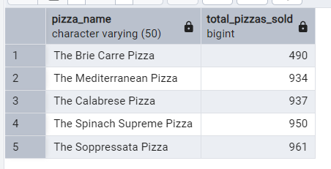

**K. Top 5 Pizzas by Total Orders**

SELECT pizza_name,

COUNT(DISTINCT order_id) AS total_orders

FROM pizza_sales

GROUP BY pizza_name

ORDER BY total_orders DESC

LIMIT 5;

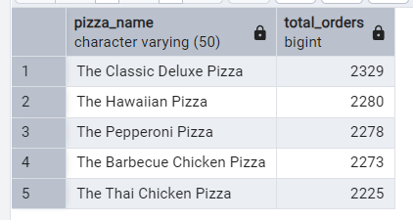

**L. Bottom 5 Pizzas by Total Orders**

SELECT pizza_name,

COUNT(DISTINCT order_id) AS total_orders

FROM pizza_sales

GROUP BY pizza_name

ORDER BY total_orders ASC

LIMIT 5;

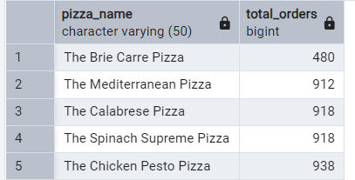

***NOTE***

If you want to apply the pizza_category or pizza_size filters to the above queries you can use WHERE clause. Follow some of below examples

SELECT pizza_name,

COUNT(DISTINCT order_id) AS total_orders

FROM pizza_sales

WHERE pizza_category = 'Classic'

GROUP BY pizza_name

ORDER BY Total_Orders ASC;